**Step 1: Connect to Azure Cloud Shell**

1. Go to the [Azure Portal](https://portal.azure.com).

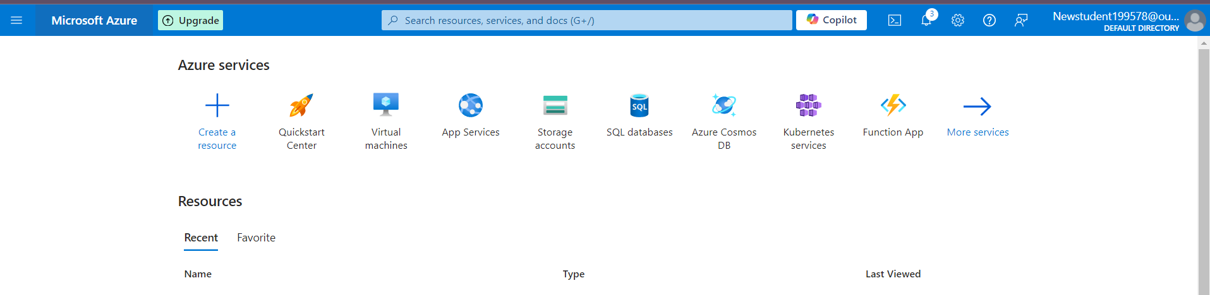

1. Click on the **Cloud Shell** icon (a terminal icon) at the top-right corner of the portal.

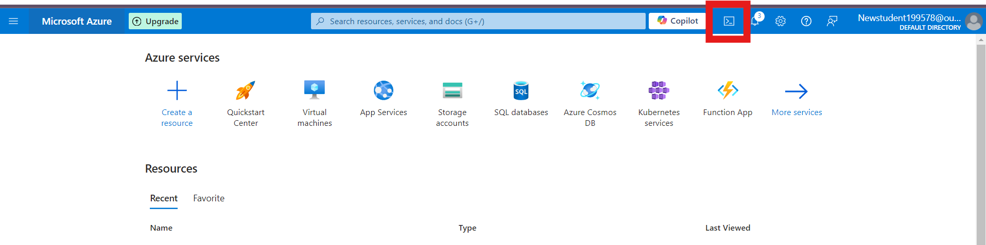

1. Select **PowerShell**.



1. The Cloud Shell will automatically connect to your Azure environment.

**Step 2: Create a Resource Group**

Once inside Cloud Shell:

**PowerShell:**

1. Run the following command to create the resource group:

**New-AzResourceGroup -Name "rg-powershell" -Location "South Central US"**

